

SCHOOL OF INFORMATICS & IT

Diploma in Big Data & Analytics

Data Mining and Business Analytics
(CDA2C02)

ASSIGNMENT 1

AY 2024/2025 OCT Semester

My Information
Name (as in matriculation card) | Adam Haizad Bin Mohamad Faizal
Admin Number | 2302276G
Practical Group (e.g. P01) | PC02
I am submitting _____ level work | Intermediate

Declaration of Originality

I am the originator of this work and I have appropriately acknowledged all other original sources used as my references for this work.

I understand that Plagiarism is the act of taking and using the whole or any part of another person’s work, including work generated by AI, and presenting it as my own.

I understand that Plagiarism is an academic offence
and if I am found to have committed or abetted the offence of plagiarism in relation to this submitted work, disciplinary action will be enforced.

Declaration on the use of Generative AI tools for assignments
Describe how you have used Generative AI tools such as ChatGPT or Dall.E- in your assignment.

Share the link to the conversations you had with the AI tool (i.e., the prompts you used and the responses you get from the AI tool).

Please refer to this PDF on “How to share the conversations made with ChatGPT?”
As stated by OpenAI (2025)
OpenAI. (2025). ChatGPT: Cramer’s V. https://chatgpt.com/share/679c88d3-47b0-8001-a4c9-a7ab255be258

As stated by OpenAI (2025)
OpenAI. (2025). ChatGPT: Assigning Weights. https://chatgpt.com/share/679ededa-5dc0-8001-96d8-12d94b3b2149
How do you indicate the reference?
The content generated by AI tools are not retrievable except by the user who generated them, so they are considered non-recoverable sources. Although non-recoverable data or quotations in APA Style papers are usually cited as personal communications, with ChatGPT-generated text there is no person communicating. Quoting text from ChatGPT chat is therefore more like sharing the output of an algorithm, with a reference list entry and the corresponding in-text citation.
According to the official APA Style site, ChatGPT references should be cited as:
E.g. OpenAI. (2024). ChatGPT (Feb 13 version) [Large language model].
https://chat.openai.com/chat

Note: The information in parentheses refers to the update or revision date of the model used. Refer to the release notes in the ChatGPT application.

Important Note:

- Do not copy answers produced by the AI tool in totality as it is considered as plagiarism.

- Do not rely on any information produced by the AI tool blindly. You should always verify the answer with other sources. Do not assume that these answers provided by the AI tool are correct.

- To achieve quality outputs from the AI tool, you should provide good prompt that is clear and specific. Be precise and provide context. Avoid asking open-ended questions.

√ | I Agree (Please Tick ü)

Name and Signature of student: ……………………………………

Date: 02/02/2025

Submitted by: 2302276G Adam Haizad Bin Mohamad Faizal

Objective of the Assignment

Data Exploration and Data Pre-processing (40 marks, 20%)

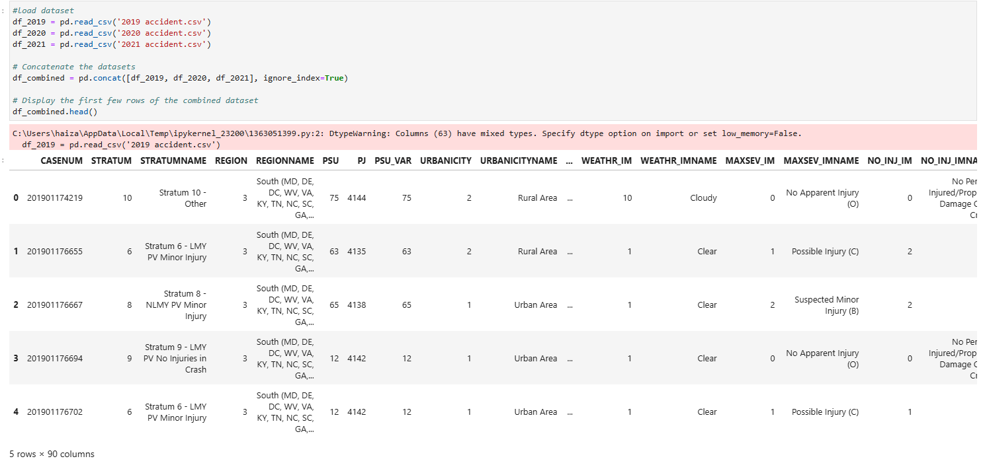

I merged the 3 datasets together which enables a thorough and comprehensive examination of the three-year accident trends. By ensuring that all relevant data is considered, it reduces potential biases from focusing on a particular year and produces more trustworthy findings.

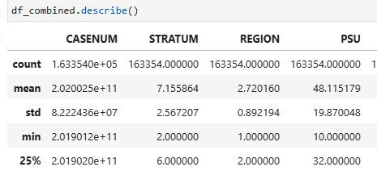
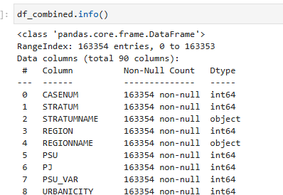

I then checked the structure and data type of the merged dataset.
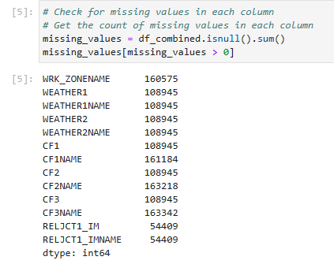

I checked for missing values for all the columns in the merged dataset and found that many of the columns had missing values.

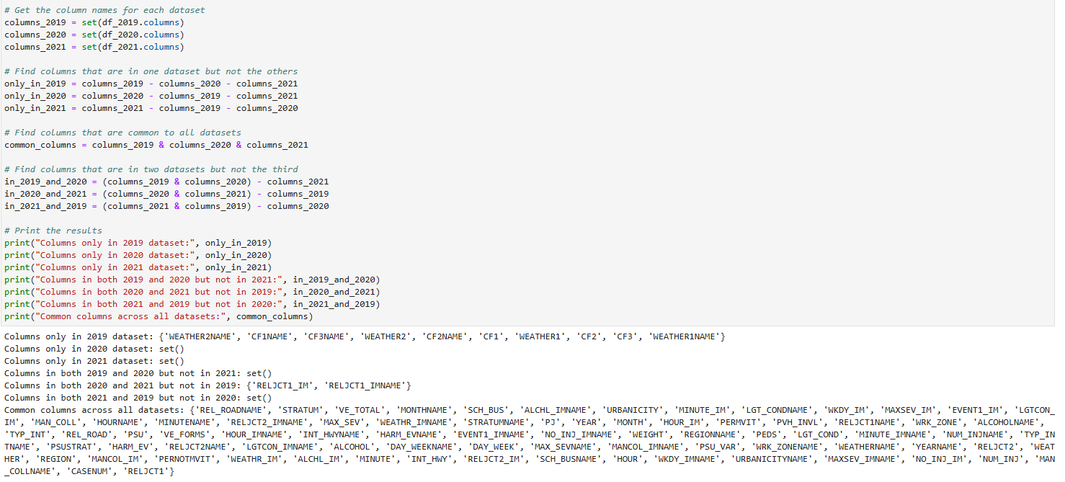

When datasets were merged, the 2019 dataset contained unique columns that were absent from the 2020 and 2021 datasets, which led to missing values in the combined dataset. 'WEATHER2NAME', 'CF3NAME', 'CF3', 'WEATHER1', 'CF2NAME', 'CF1', and 'WEATHER1NAME' are some of these fields. Because they lack matching data, rows from the 2020 and 2021 datasets have NaN values in these columns upon merging. RELJCT_IM and RELJCT_IMNAME were present in 2020 and 2021 datasets but not in 2019 dataset, which resulted in NaN values. When integrating datasets with different schemas, this frequently happens.
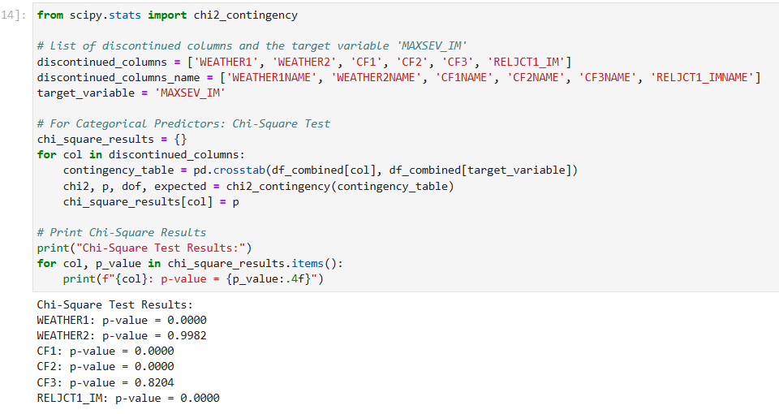
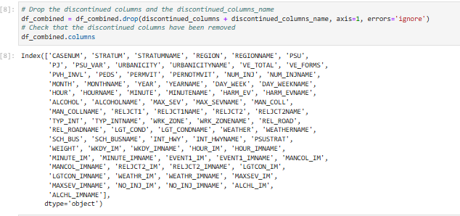

I plotted the findings and performed Chi-Square tests to evaluate the relationships between WEATHER1, CF1, CF2, RELJCT1_IM, and MAXSEV_IM. Due to their large percentage of missing values, which resulted from their disappearance in certain datasets, these columns were difficult to keep even though some had significant relationships with MAXSEV_IM (p < 0.05). It would take a lot of imputation to fill in these missing data, which could introduce noise and lower model reliability. Despite their importance, I dropped the columns (WEATHER1, WEATHER2, CF1, CF2, CF3, RELJCT1_IM) to simplify preprocessing and preserve a clean and uniform dataset.
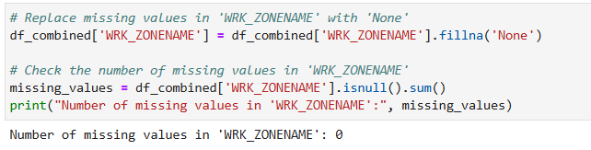
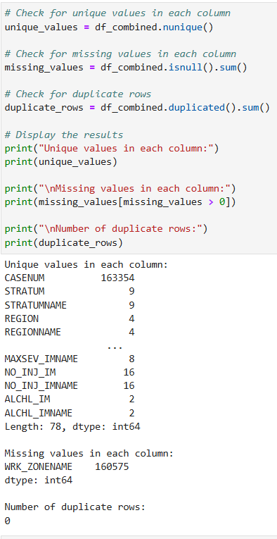

I checked for duplicate rows, missing values, and unique values in the dataset. Although there were no duplicate entries in the results, 160,575 missing values in the WRK_ZONENAME column were found. After looking into it, I found that the missing numbers in this column were left empty because they represent accidents that did not happen in a work zone. I fixed this by substituting 'None' for the missing values, making it clear that these accidents had nothing to do with a work zone.
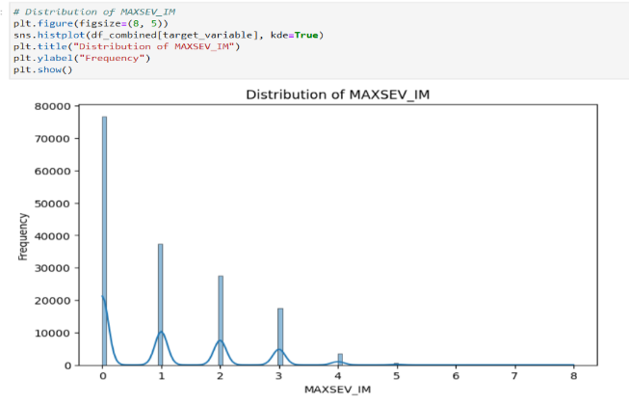

The plot indicates that MAXSEV_IM is highly unbalanced, with most occurrences falling into the lower severity categories such as 0 and 1 and a significantly lower frequency of higher severity levels of 4 and above. To remove potential biases during model training, this mismatch emphasizes the necessity of methods like resampling, class weighting, or specialized assessment measures. To create a strong and trustworthy classification model, it is important to comprehend this class distribution.

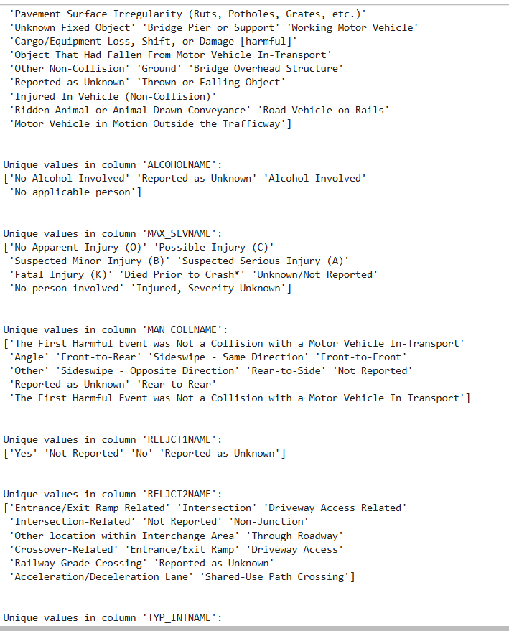
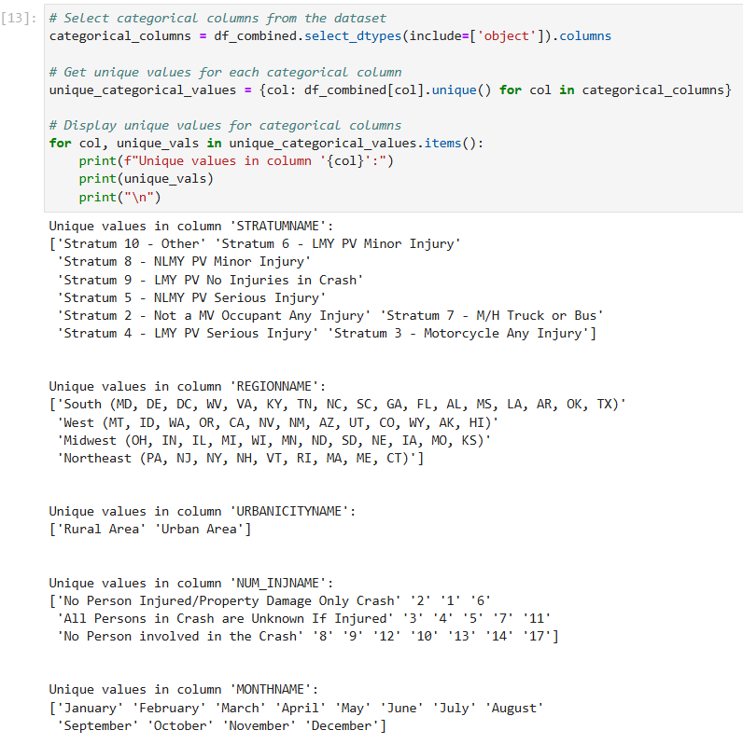
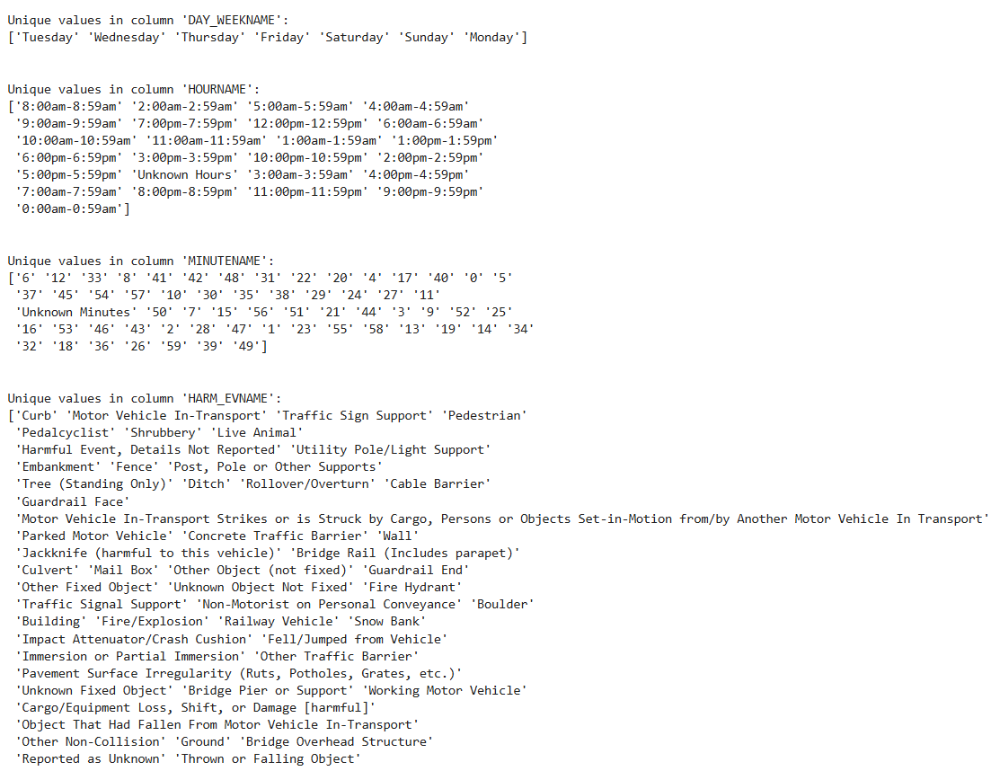

I then displayed the unique values for each categorical column to check for inconsistency. After looking through each unique value, I can confirm that there are no data inconsistencies in the merged dataset.

I next checked for target leakage, which causes excessively optimistic performance metrics when a model unintentionally incorporates data that wouldn't be available during actual predictions. As a result, the model may function well during training but poorly during usage in real life. I examined each variable using my domain expertise and concluded that none of them could result in target leakage.

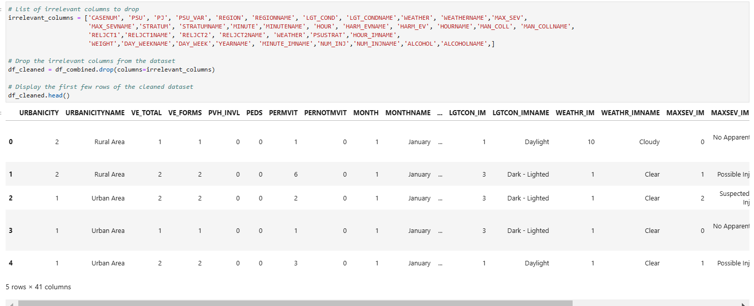

I then dropped all the unnecessary columns such as CASENUM and PSU_VAR which were not useful in predicting the target variable ‘MAXSEV_IM’. In the dataset, there is a variable that is the original and one that is imputed, which excludes the unknown values. For example, there is a column LGT_COND which is the original and LGTCON_IM, which is the imputed column. I dropped all the original columns, including its names and kept the imputed columns and its name. By using the imputed columns, I reduce the chance of adding noise or errors to the model and guarantee that the dataset only contains accurate and significant data. The accuracy and reliability of the model may be negatively impacted by missing or unknown values in the original columns, which is particularly crucial when predicting the target variable MAXSEV_IM. I also dropped some imputed name columns such as MINUTE_IMNAME as its values were the same as the imputed column MINUTE_IM.

Research on the domain of the assignment

An in-depth knowledge of road accidents is necessary for effective safety measures, and the National Highway Traffic Safety Administration (NHTSA) is leading the charge in this regard. Since its founding in 1970, NHTSA has collected and analyzed vast amounts of crash data using tools such as the Crash Report Sampling System (CRSS). This data includes a variety of variables, such as weather, road factors, driver behavior, car specifications, and accident results. Through maintaining and updating of these extensive datasets, NHTSA makes it possible for researchers to identify patterns, evaluate risk factors, and gauge how well safety measures and efforts that aim to lower traffic fatalities and injuries are working.

Many factors, including speeding, driving while intoxicated, distracted driving, badly built roads, bad weather, the location and age of the driver, as well as the age and condition of the vehicle, can lead to traffic accidents. Developing predictive models that precisely predict the probability and severity of accidents requires an understanding of how these variables interact. Driving when intoxicated or distracted, for instance, significantly increases the chance of severe crashes. However, vehicle maintenance and safety measures like airbags and seat belts can help lessen the severity of injuries. Poor visibility, slippery roads, and high traffic are examples of environmental factors that not only raise the likelihood of accidents but also increase their potential severity.

Through this research, I understood more about the factors that can cause traffic accidents and I can apply what I have learned to identify the variables that have the most influence in predicting the target variable MAXSEV_IM.
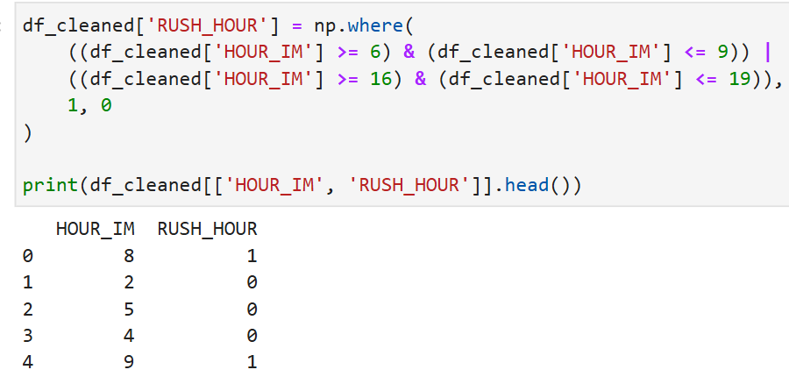

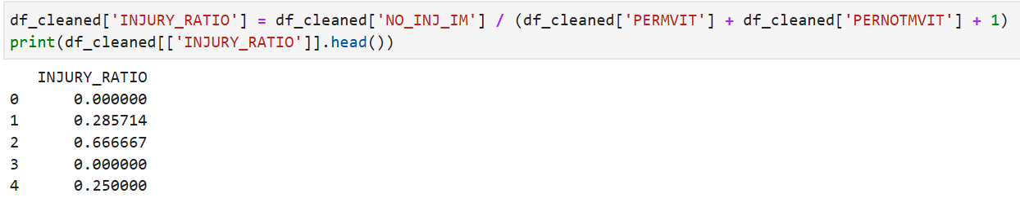
I developed the RUSH_HOUR feature as a binary numeric variable which is 0 as no or 1 as yes to determine whether an incident happened during regular rush hours which is 6–9 AM or 4–7 PM. This feature provides information about the impact of high traffic periods by capturing the possible relationship between accident severity and time of day.

To show the percentage of injured people (NO_INJ_IM) compared to all accidents individuals, including those in motor vehicles (PERMVIT) and those not in motor vehicles (PERNOTMVIT), the INJURY_RATIO feature was created. By offering a standardized indicator of injury severity, this normalized ratio makes it possible to make insightful comparisons across crashes of different sizes and situations. This feature can assist in determining trends in the severity of injuries, evaluating the impact of crashes, and prioritizing safety initiatives for groups by taking into consideration both motor vehicle occupants and non-motor vehicle individuals. It improves the model's capacity to represent incident severity and relative risk, providing insightful information for resource allocation and decision-making in traffic safety analysis.
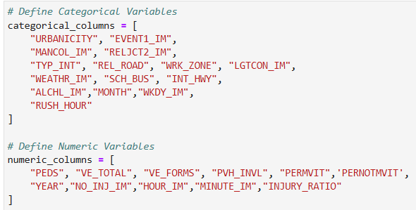

I divided the variables into numeric and categorical groupings to apply the proper statistical techniques. Numerical variables like VE_TOTAL and INJURY_RATIO was analyzed using the Variance Inflation Factor (VIF) to identify multicollinearity, while categorical variables like URBANICITY and TYP_INT were analyzed using Cramér's V or Chi-Square tests to evaluate relationships. This division facilitates a systematic feature selection procedure and guarantees reliable analysis.
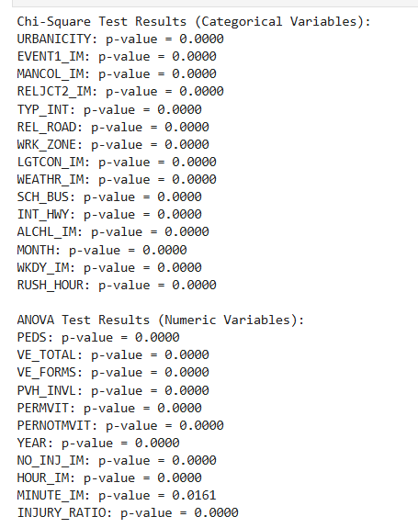
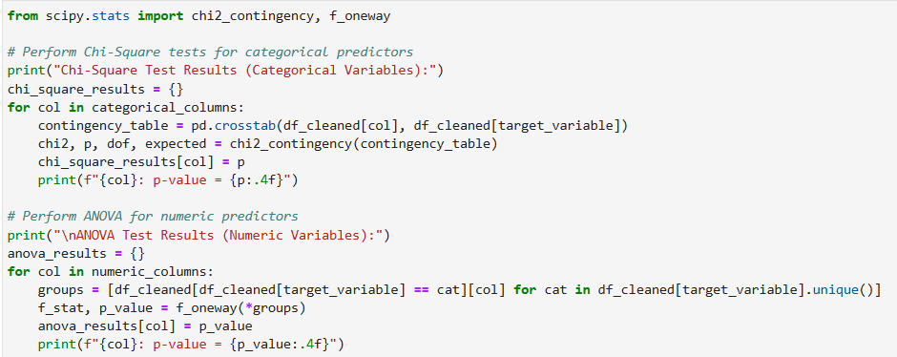

According to the findings of the Chi-Square test for categorical variables, every examined variable (such as URBANICITYNAME, EVENT1_IM, and TYP_INT) has a p-value of 0.0000, indicating a significant relationship with the target variable. This indicates that these variables should be considered in further analysis since they are probably significant predictors. Similarly, the ANOVA findings for numerical variables show that most of the variables (such as PEDS, VE_TOTAL, VE_FORMS, and PVH_INVL) have a p-value of 0.0000, suggesting that they are potentially significant predictors and that their means differ considerably among target groups. To determine the significance of borderline cases like MINUTE_IM (p-value = 0.0161), more investigation may be necessary. To improve the model's performance, highly significant variables should generally be given priority, while redundant or insignificant variables may be eliminated.

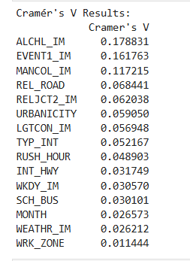
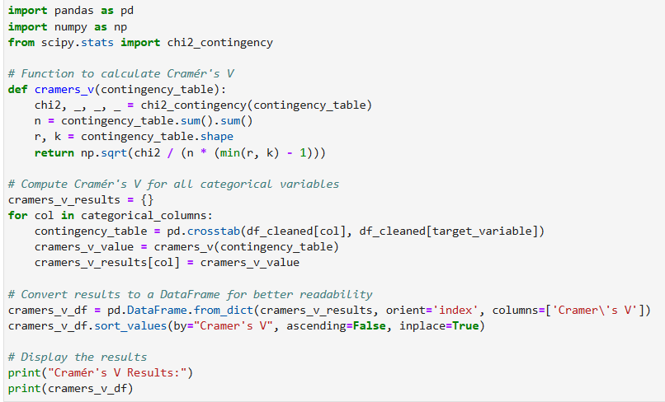

The degree of correlation between each categorical variable and the target variable, MAXSEV_IM, is determined by the Cramér's V analysis. The strongest correlations are seen between variables like ALCHL_IM with 0.1788 and EVENT1_IM with 0.1618, suggesting that they may be important predictors. Moderate associations that potentially add to the model but have less of an impact than the top predictors are suggested by mid-range values such as REL_ROAD with 0.0684 and URBANICITY with 0.0590. In contrast, variables such as WEATHR_IM with 0.0262 and WRK_ZONE with 0.0114 exhibit very weak relationships and could not have much predictive power. While weaker variables may be eliminated to simplify the model unless domain expertise justifies their inclusion, these results offer guidelines for feature selection by giving priority to variables with greater associations.
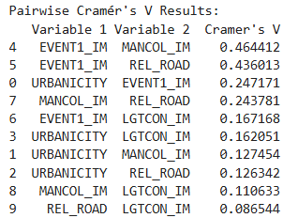
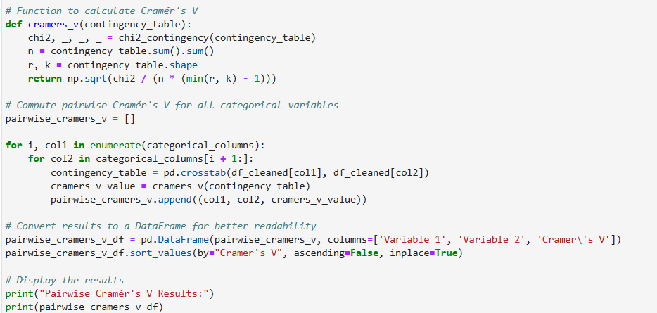

The amount of association among categorical variables is shown by the pairwise Cramér's V analysis; stronger relationships are indicated by higher values. EVENT1_IM and MANCOL_IM have the strongest correlation with 0.464, followed by EVENT1_IM and REL_ROAD with 0.436, indicating a moderate overlap in the data they record. Less redundancy is indicated by lower relationships between variables such as URBANICITY and EVENT1_IM with 0.247 and MANCOL_IM and REL_ROAD with 0.243. These findings suggest that while variables with low associations can be kept since they offer valuable insights, variables with high affiliations may be redundant and one of each pair could be removed to make the dataset simpler. From the previous Cramér's V analysis, we identified that ALCHL_IM and EVENT1_IM would be important predictors, and from this Cramér's V analysis, we can include both these predictors in the model since they are not associated with each other. After further evaluation, with the use of my domain knowledge, I felt that including RUSH_HOUR and TYP_INT would be beneficial to the model, and there is no strong association between RUSH_HOUR and TYP_INT and with the other predictors.
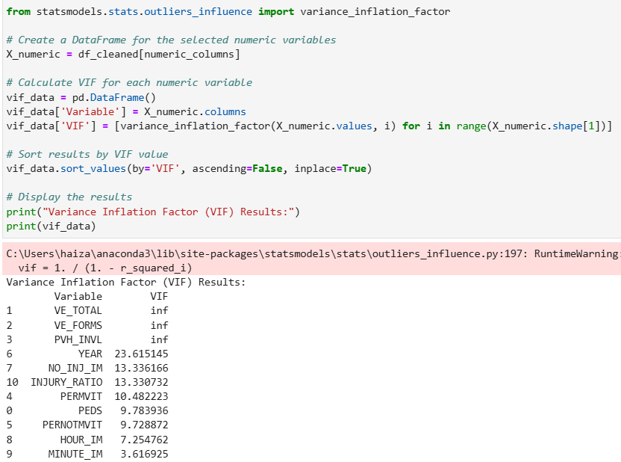

The Variance Inflation Factor (VIF) results demonstrate significant multicollinearity among various numerical variables; specifically, VE_TOTAL, VE_FORMS, and PVH_INVL show infinite VIF values, indicating perfect multicollinearity. The strong multicollinearity of variables like YEAR with 23.62, NO_INJ_IM with 13.34, INJURY_RATIO with 13.33, and PERMVIT with 10.48 further suggests redundancy. Since INJURY_RATIO is calculated using NO_INJ_IM, PERMVIT, and PERNOTMVIT, adding them all leads to multicollinearity. Therefore, to avoid multicollinearity, I would just put INJURY_RATIO in the model.

Therefore, my predictors are, INJURY_RATIO, EVENT1_IM, ALCHL_IM, RUSH_HOUR and TYP_INT

Predictive Modelling (40 marks, 20%)

Research on various machine learning algorithm (data mining models) and their respective assumptions

The first step in preparing for machine learning projects is to understand each of the algorithms you intend to employ and their needs. With a particular focus on models such as Neural Networks, Decision Trees, Logistic Regression, each makes distinct assumptions about the data. For example, a linear relationship between the log chances of the outcome and the predictors is expected when using logistic regression for binary classification. In contrast to neural networks, which are excellent at capturing complex, non-linear correlations but require large data and thorough feature engineering, decision trees are flexible for both classification and regression without making strict assumptions about data distribution. Knowing these assumptions will help you choose the best algorithm for the situation and make sure it works properly with your dataset.

The next crucial step is to get your data ready to meet these algorithmic assumptions. Encoding categorical variables into numerical representations, fixing missing values, eliminating outliers, and scaling features to ensure an equal contribution to the model are all part of this process. Use feature selection or dimensionality reduction to deal with multicollinearity in linear and logistic regression. While Neural Networks require significant preparation, such as normalizing inputs and supplementing data to expand dataset size, Decision Trees require accurate encoding and imputing of missing values to create clear decision paths. Furthermore, feature engineering and selection aid in highlighting the most important elements of your data, improving the precision and effectiveness of your model.
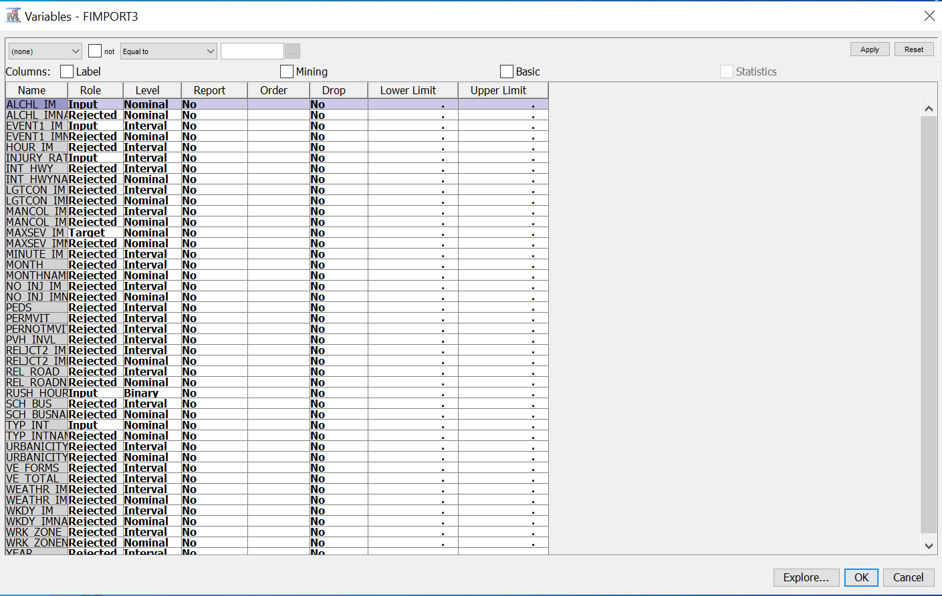
Lastly, it's critical to assess and validate your models to make sure they meet their assumptions and operate consistently. Utilize methods such as residual analysis for regression models to find assumption violations and cross-validation to evaluate generalization with new data. Examine feature importance and model complexity for decision trees and neural networks to avoid overfitting and improve interpretability. This assessment procedure can be accelerated by utilizing SAS Enterprise Miner's model implementation, data manipulation, and visualization capabilities. Strong algorithmic knowledge, careful data preparation, and in-depth model evaluation can all be combined to create machine learning models that are reliable and efficient for your specific needs.

I imported the dataset from JuypterLab to SAS EM. After importing the dataset, I then set the roles of the variables to either rejected, input or target and change their label to the correct one as some were wrong such as ALCHL_IM incorrectly labelled as interval when it should be nominal. The target is none other than MAXSEV_IM. I set the variables, EVENT1_IM, ALCHL_IM, TYP_INT, INJURY_RATIO and RUSH_HOUR as inputs since they are the predictors.

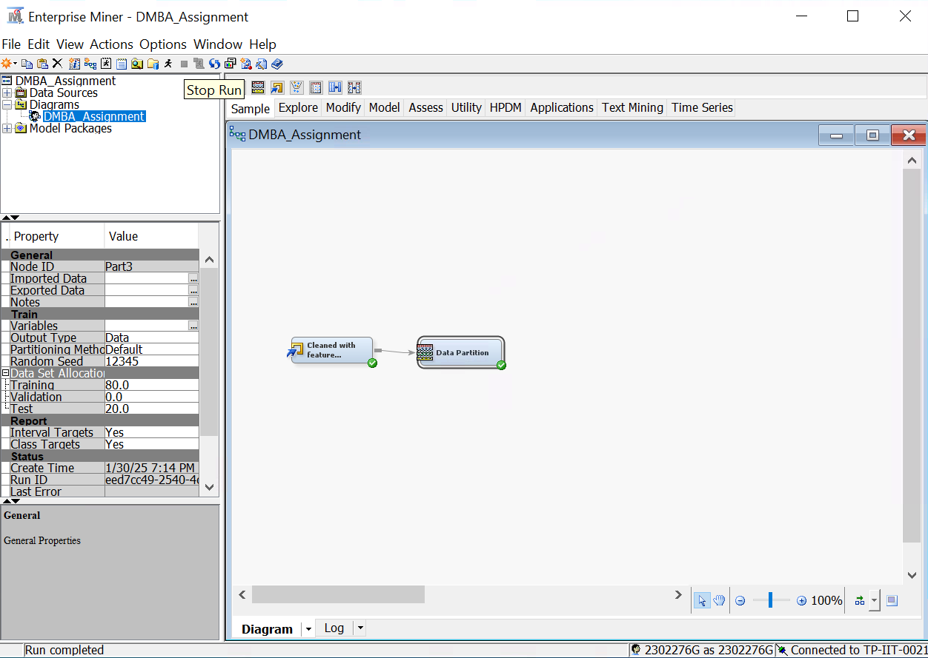

I then added the data partition node to the dataset and split the data into 80% training and 20% testing
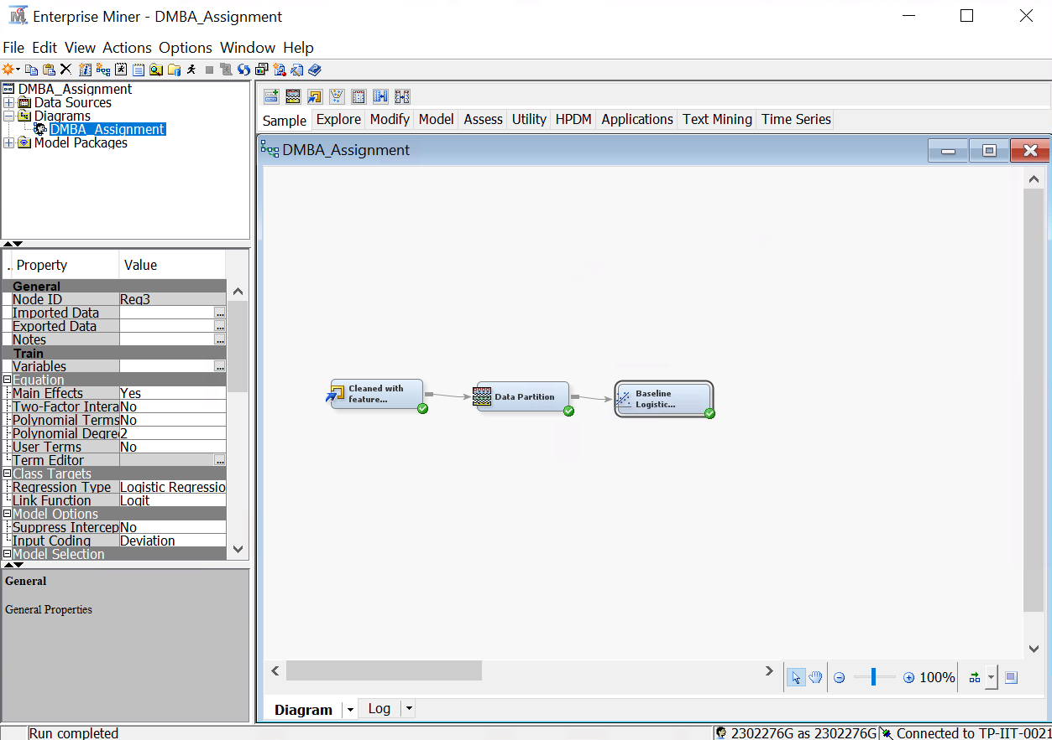

I then added the regression node to the dataset, changed the regression type setting to logistic regression and performed it with the default settings.

Evaluation Techniques Research: Research on various model evaluation techniques and discuss why your eventual selected evaluation criteria is the most appropriate.

We evaluated our machine learning models using a variety of classification metrics, including Accuracy, Precision, Recall, F1 Score, and the Confusion Matrix. Since F1 Score offers a balanced measure of precision and recall, we opt for using it and accuracy as our primary evaluation criteria. This ensures that the model performs well even when there is a class imbalance. In contrast, accuracy provides a clear evaluation of the model's frequency of accurate predictions across all classes.

These two metrics work in unison to guarantee that our models are precise and relevant by offering information on both overall accuracy and the ratio of false positives to false negatives. Furthermore, by looking at the Confusion Matrix, we can better comprehend the model's advantages and disadvantages in several categories. This combination guarantees that the model accurately depicts the relationships present in the data while enabling us to objectively assess its accuracy.

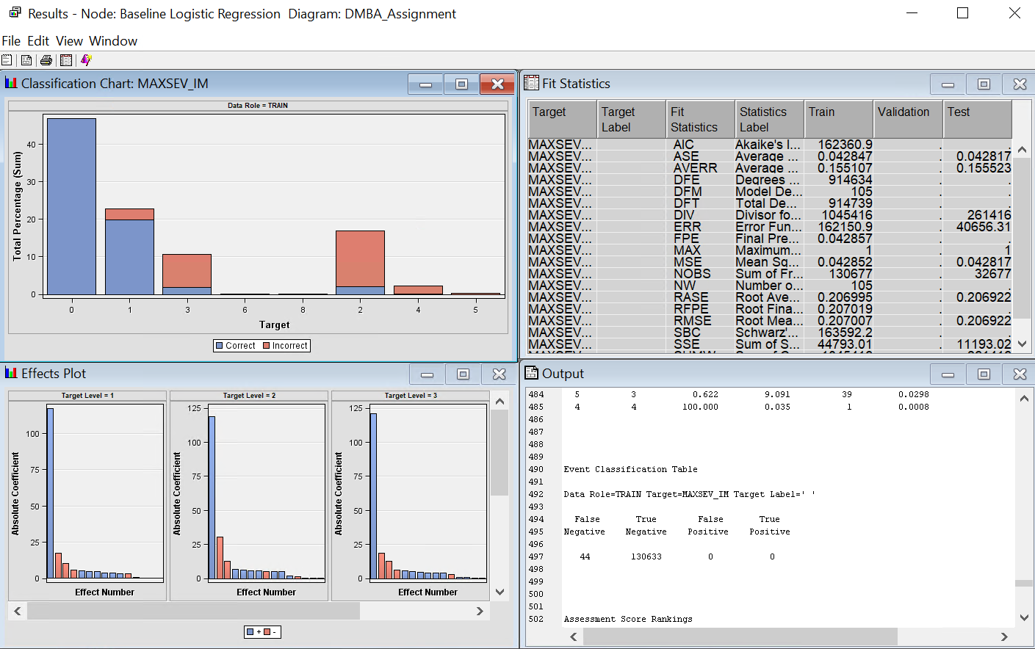
Baseline Logistic Regression model

Metrics calculation:

Accuracy: (130633+0)/ (130633+0+44+0) = 99.97%

Precision: 0/ (0+44) = 0

Recall = 0/ (0+0) = 0

F1-score = 0

As the classification table shows, the baseline logistic regression model's high accuracy of 99.97% is misleading since it biases the majority class (0). The model performs well for class 0 (blue bars for correct predictions dominate), but it considerably underperforms for minority classes (3, 4, 5), that have many incorrect predictions (red bars).

The model is unable to detect any instances of minority classes, as seen by the precision, recall, and F1-score all being 0. This poor performance emphasizes the need for changes, like using class weights, oversampling, or under sampling to correct class imbalance. As demonstrated by the metrics and classification table, the model's applicability for accurately predicting higher severity levels is limited by its reliance on the majority class.

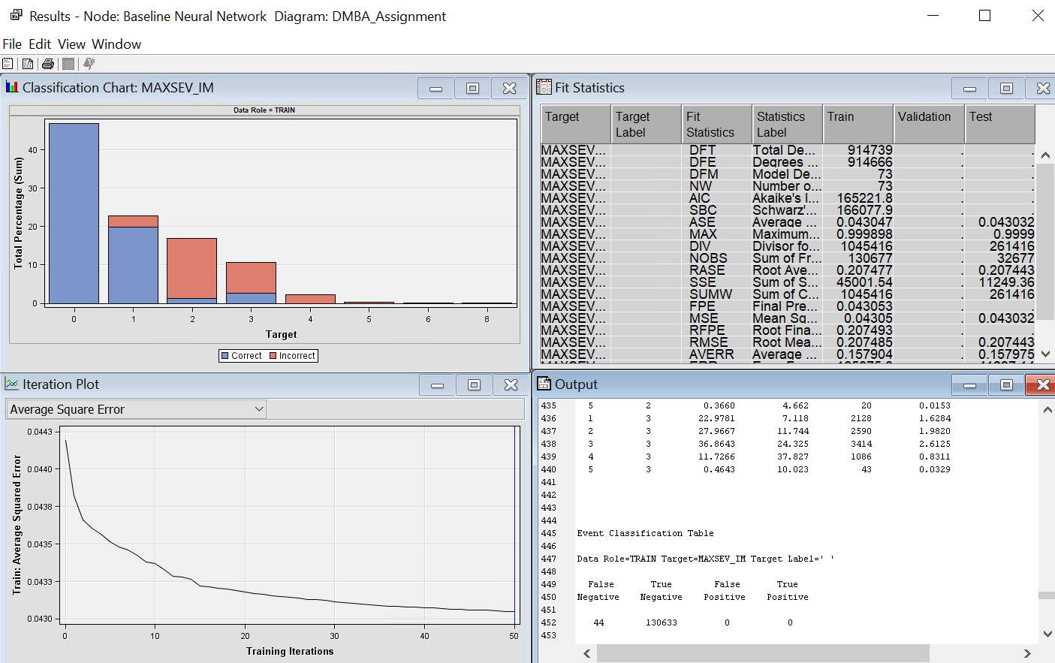
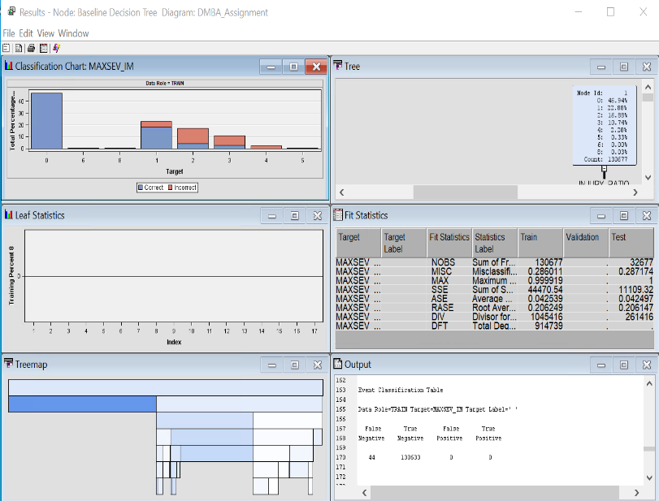
Baseline Decision Tree Baseline Neural Network

To determine whether the observed class imbalance was a problem unique to linear regression, I then created a decision tree and a neural network, both of which were ran with default settings. However, the findings show that the class imbalance is consistent across all models, indicating that it is not a weakness of a particular technique but rather a basic feature of the dataset.
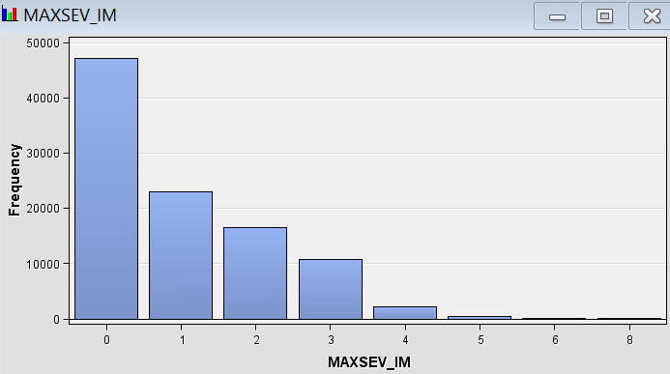

Class 0 dominates the sample, indicating a significant class imbalance in the MAXSEV_IM distribution. Poor performance on minority classes may result from the logistic regression model favouring the majority class due to this imbalance. I addressed this by assigning weights based on the classes and undersampling class 0 to lessen its dominance. The model performs better across all classes, especially the under-represented ones, thanks to these modifications.
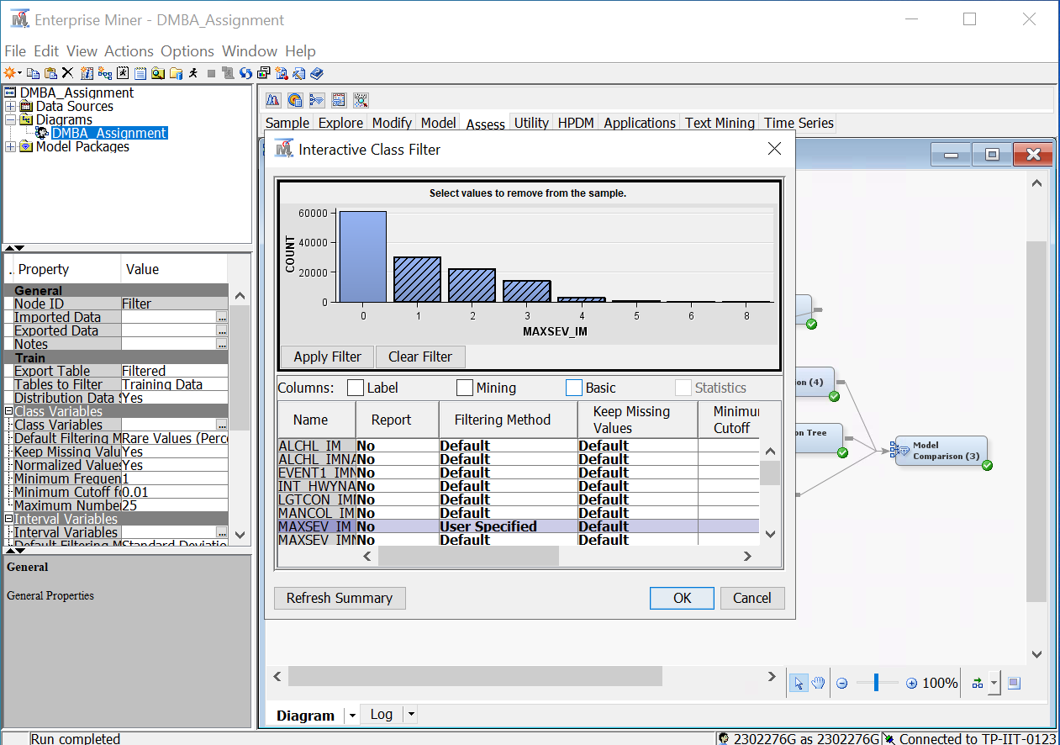

To balance the dataset and successfully solve class imbalance, I created a filter node to separate class 0 values, enabling targeted undersampling.

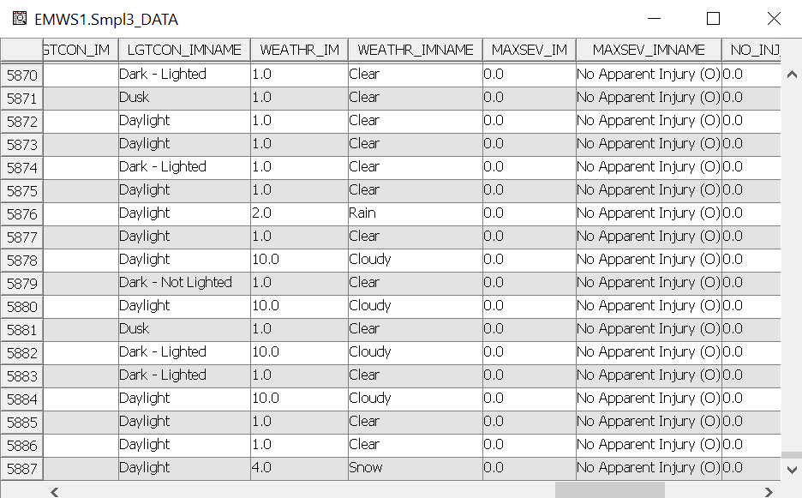
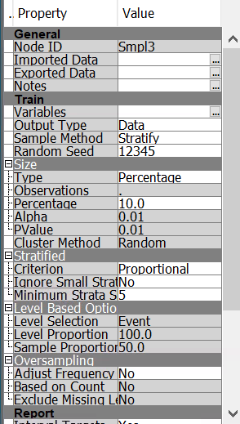

I undersampled Class 0 using the Sample node and the stratify method to fix the dataset's class imbalance. The method of sampling was designed to maintain proportional representation of the data while reducing Class 0 to 10% of its initial size. Without compromising the dataset's general structure or balance, this procedure was successful because the number of rows for Class 0 dropped significantly from 58,871 to 5,887. Better model performance on the minority classes is made possible by this undersampling, which makes sure that Class 0 does not dominate the analysis.
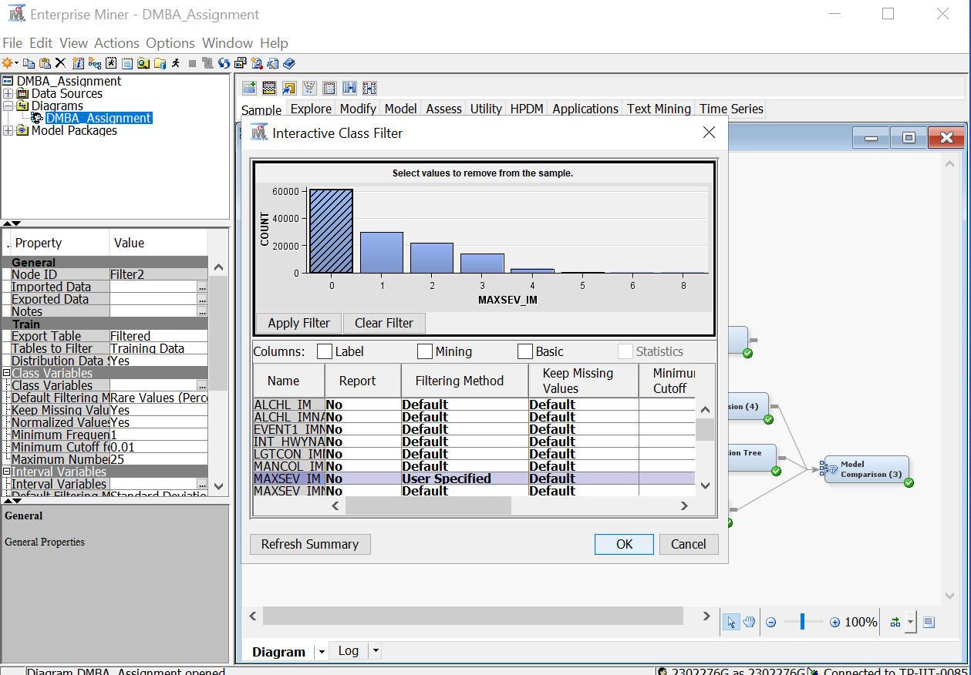

I will now assign weights based on the classes after undersampling Class 0. To ensure that the under-represented classes are the focus, I first filtered the data to remove Class 0. This enables me to highlight their significance by allocating suitable weights, which will lessen the impact of class imbalance and balance their influence throughout the model training process.

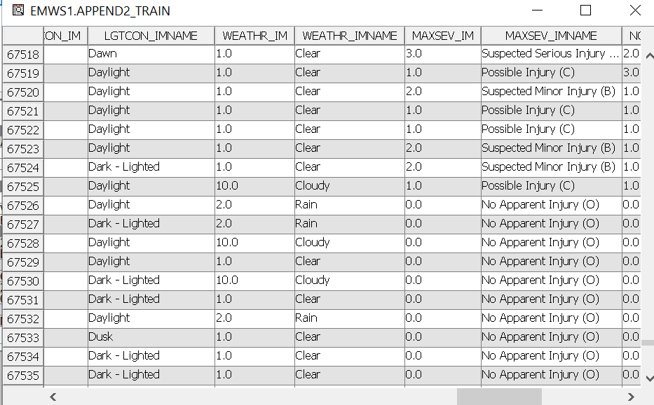
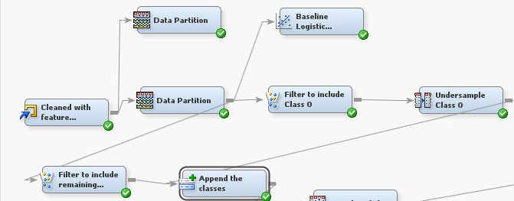

I then combined the filtered dataset with the remaining classes and the undersampled Class 0 using the append node. By ensuring that every class is present in the final dataset, this phase makes it possible to assign each class the proper weights. I can more successfully handle class imbalance by reuniting the datasets and adjusting weights to account for the importance of the under-represented classes during model training.

I then added a transform variable node to the append node so that I can create a new column named ClassWeight which will be the column that assigns weight based on classes. (Referenced from ChatGPT. Link shown in reference pg)

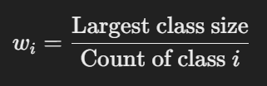

I used the formula:

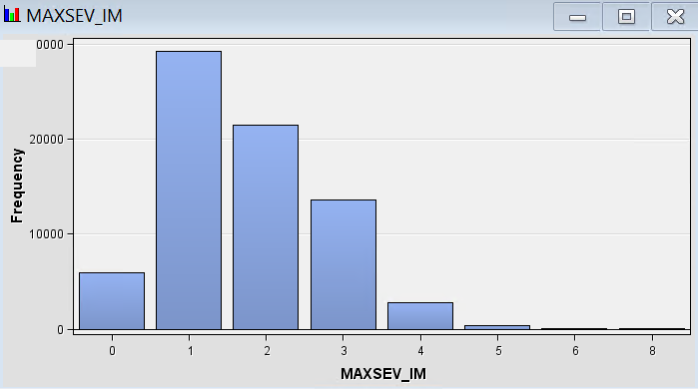

Based on the distribution, the largest class is class 1 with 29,232 frequencies. We will use it as the largest class size. The calculations for each class weight are shown below.

Class 0 weight: 29,232 / 5887 = 4.96

Class 1 weight: 29,232 / 29,232 = 1

Class 2 weight: 29,232 / 21,467 = 1.36

Class 3 weight: 29,232 / 13,616 = 2.15

Class 4 weight: 29,232 / 2753 = 10.62

Class 5 weight: 29,232 / 415 = 70.42

Class 6 weight: 29,232 / 4 = 7308

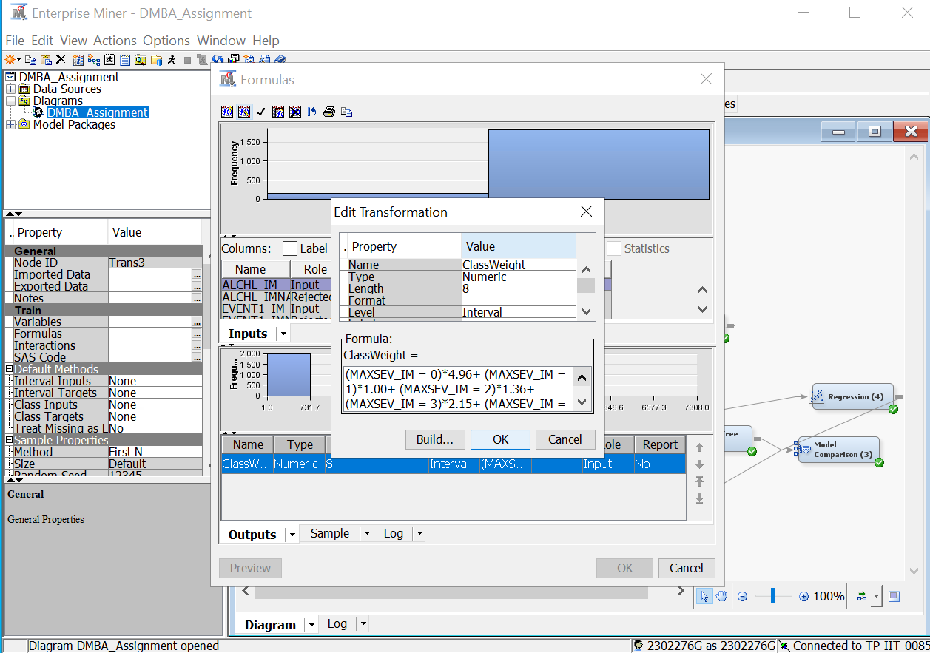
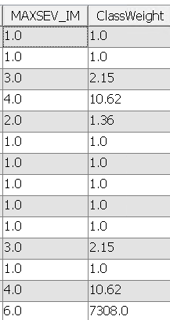
Class 8 weight: 29,232 / 38 = 769.26

I then entered a custom formula into the Transform Variables node in the formula setting to apply the calculated weights to the classes. Each class is given a specific weight by the formula according to its value in the MAXSEV_IM variable. The formula is set up as follows:

(MAXSEV_IM = 0)*4.96

+ (MAXSEV_IM = 1)*1.00

+ (MAXSEV_IM = 2)*1.36

+ (MAXSEV_IM = 3)*2.15

+ (MAXSEV_IM = 4)*10.62

+ (MAXSEV_IM = 5)*70.42

+ (MAXSEV_IM = 6)*7308

+ (MAXSEV_IM = 8)*769.26

The formula was successful, and the weights were assigned based on the classes which can be seen in the right picture above this text. The model's capacity to take under-represented classes into consideration during training will be enhanced by this modification.

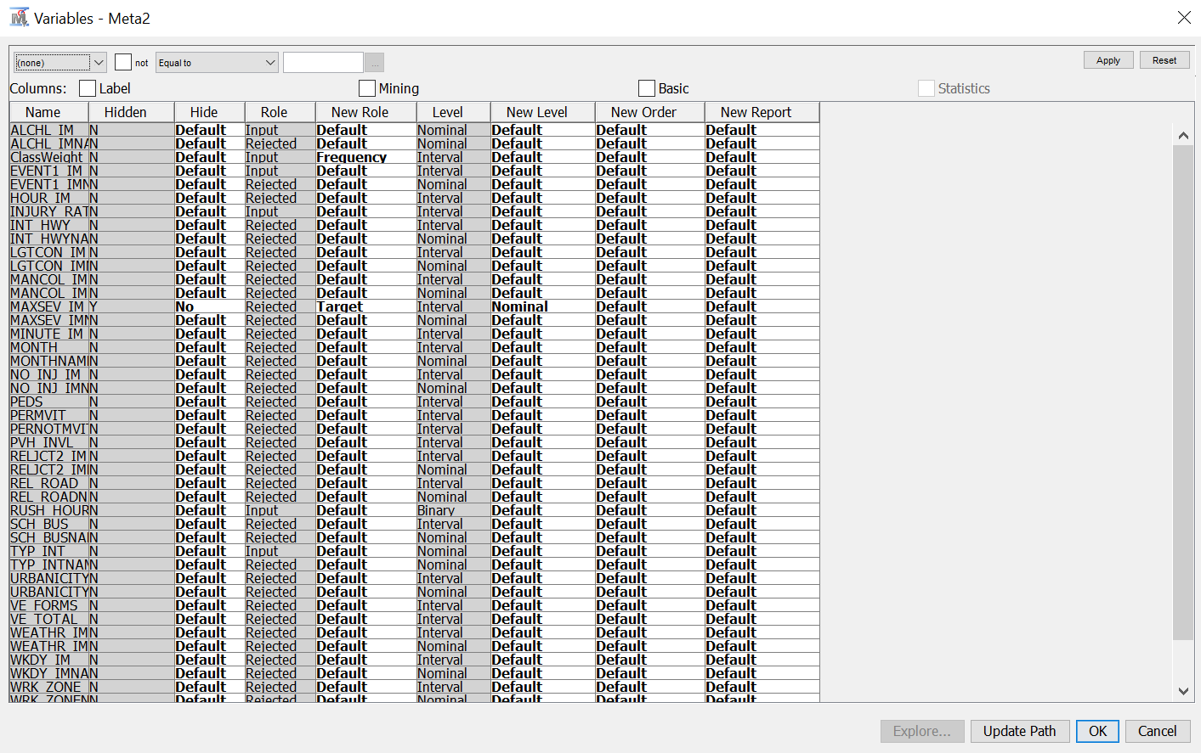

The newly created column, ClassWeight, was then incorporated into the model by adding a Metadata node. I gave the ClassWeight column in the Metadata node the Frequency role. This function makes sure that during training, the model considers the weights allocated to each class. In particular, the Frequency function modifies each observation's impact according to its weight. Also, there were some not accounted for changes made to MAXSEV_IM such as it was hidden and it was not the target, so I changed it back.

With all the changes made to the classes, I will now perform logistic regression again to see if there are any improvements.
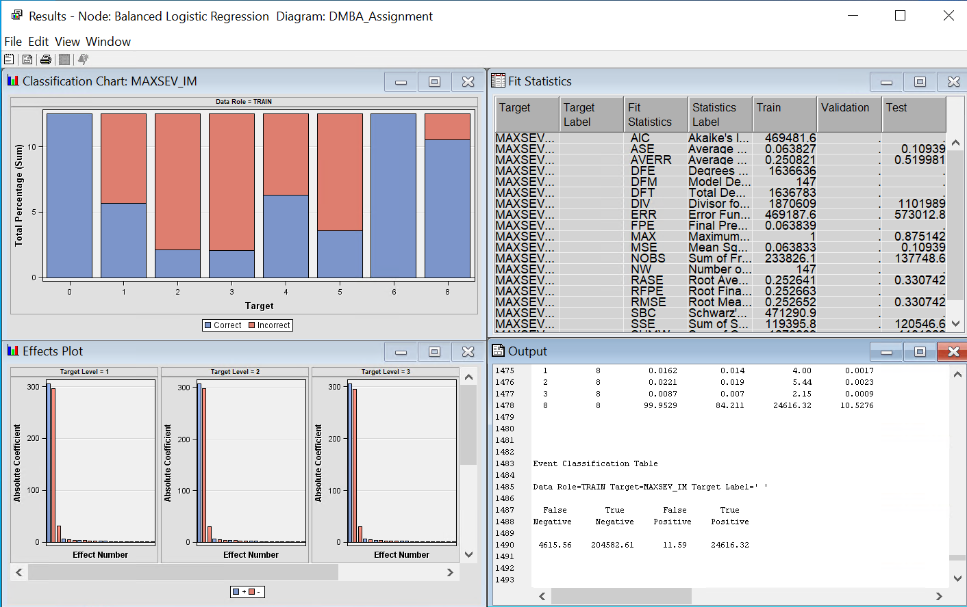
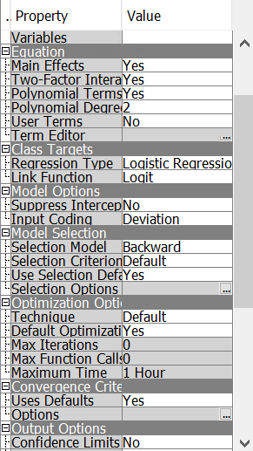

To increase the performance of the logistic regression, I adjusted the settings to allow polynomial terms, which consider non-linear correlations between predictors and the target, and two-factor interactions, which capture the combined effects of variable pairs. I also changed to backward regression, which removes less important variables from the model so that only the most important predictors are left.

Metrics calculation:

Accuracy: (204582.61+4615.56)/(204582.61+4615.56+11.59+24616.32)=89.47%

Precision: 204582.61/(204582.61+11.59)=99.99%

Recall = 204582.61/(204582.61+24616.32)=89.26%

F1-score = 2*(99.99%*89.26%)/(99.99%+89.26%)=94.32%

The model performs exceptionally well on the training data, achieving 89.47% accuracy, 99.99% precision, 89.26% recall, and a 94.32% F1-score. These metrics show that, as seen in the classification chart, the model successfully classifies the training data with no problems of class imbalance. But because these measurements are only based on training data, the high numbers could be a sign of overfitting, which would mean the model doesn't generalize well to test data that hasn't been seen yet.

Neural Network Decision Tree
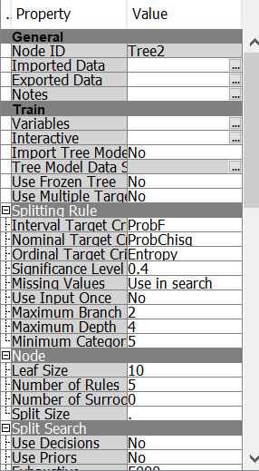
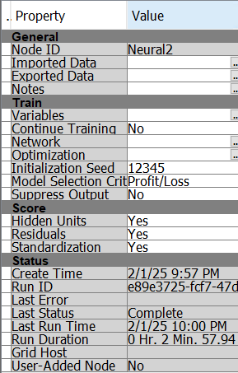

To find out if the speculated overfitting problem remains true for different models, I decided to include both a Decision Tree and a Neural Network node. I changed the leaf size from 5 to 10, decreased the maximum depth from 6 to 4, and raised the significance level to 0.4 from 0.2 to reduce overfitting in the Decision Tree settings. The aim of these modifications is to enhance the generalization of the tree structure and simplify it. I enabled standardization and enabled hidden units for the Neural Network to combat overfitting. These modifications guarantee that the model more effectively generalizes to unknown data and enhance the stability of the training procedure.

Decision Tree Neural Network

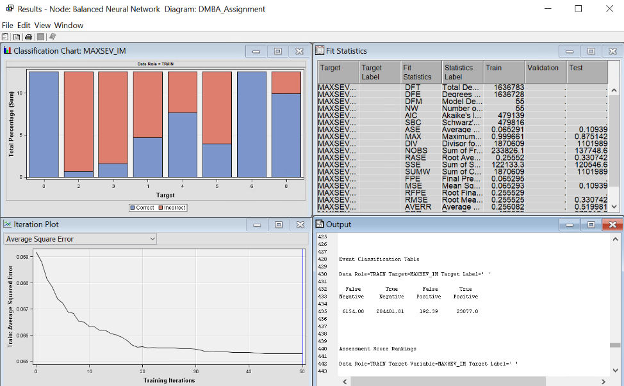
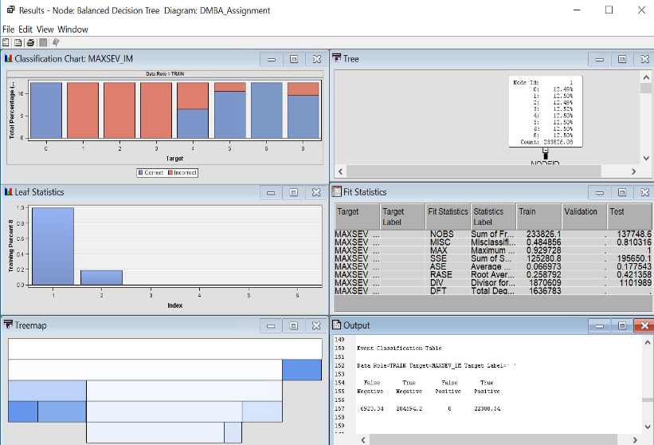

Decision Tree metrics calculation:

Accuracy: (22,308.54+204,594.20)/(22,308.54+0+204,594.20+6,923.34)=97.04%

Precision: 22,308.54/(22,308.54+0)=100.00%

Recall = 22,308.54/(22,308.54+6,923.34)=76.32%

F1-score = 2*(100.00%*76.32%)/(100.00%+76.32%)=86.57%

The decision tree model's accuracy, precision, recall, and F1-score are 97.04% , 100.00%, and 76.32%, respectively. Although all positive predictions are accurately captured by the model, its reduced recall suggests that it misses a sizable percentage of real positives. The logistic regression model, in contrast, has an F1-score of 94.32%, an accuracy of 89.47%, a precision of 99.99%, and a recall of 89.26%. Finding true positives and reducing false positives are better balanced in this model. The recall indicates that it is marginally better than the decision tree in capturing actual positive cases, despite its high precision. However, the issue of overfitting is still present as the results for both the decision tree and logistic regression is too good to be true.

Neural Network metrics calculation:

Accuracy: (204401.81+6154.08)/(204401.81+6154.08+192.39+23077.8)=90.05%

Precision: 204401.81/(204401.81+192.39)=99.91%

Recall = 204401.81/(204401.81+23077.8)=89.86%

F1-score 2*(99.91%*89.86%)/(99.91%+89.86%)=94.61%

The neural network model has a recall of 89.86%, a strong precision of 99.91%, and a relatively high accuracy of 90.05%. This implies that even while the model is very good at accurately detecting positive cases, some real positives are still missed. It is a powerful classifier overall, as evidenced by its F1-score of 94.61%, which shows a solid balance between precision and recall. In contrast, the decision tree model and logistic regression both attain high F1-scores of 86.57% and 94.32%, respectively. While the decision tree has perfect precision but lower recall, suggesting that it may be more conservative in classifying positive situations, logistic regression offers an improved balance between capturing true positives and minimising false positives. Despite the neural network's excellent accuracy and precision, overfitting may occur because of its robust performance on training data, which could impair its capacity to generalise effectively to new data. To verify the model's practical effectiveness, additional testing on the testing set would be required.

In SAS em, it doesn’t show the confusion matrix for the test data so one way to find out if the models overfit is by the model comparison node.

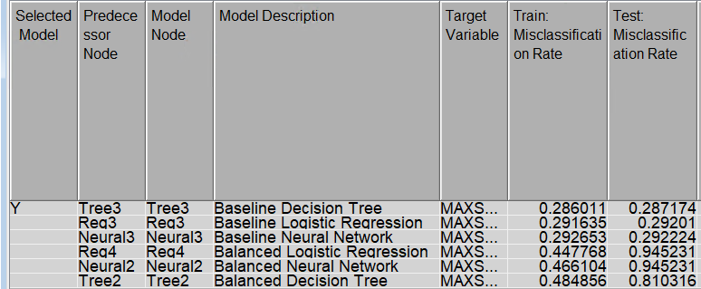
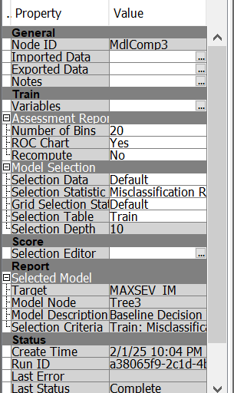

I added the model comparison node and used misclassification rate as the selection statistic because it offers a straightforward indicator of how effectively each model classifies the severity of injuries. The misclassification rate is a simple indicator for comparing the efficacy of models since it shows the percentage of cases that were incorrectly predicted out of all the predictions.

There are little indications of overfitting in the baseline models, which include the neural network, logistic regression, and decision tree. The near misclassification rates of the training and test datasets make this clear. Consistent performance across datasets is demonstrated by the Baseline Decision Tree (Tree3), which attains a training misclassification rate of 28.60% and a test misclassification rate of 28.71%. Similarly, the Baseline Logistic Regression (Req3) achieves rates of 29.16% and 29.21%, respectively, while the Baseline Neural Network (Neural3) has training and test misclassification rates of 29.27% and 29.22%. Even with their impressive results, these baseline models continue to suffer from class imbalance, under-representing the minority class and favouring the dominant class.

The balanced models, which aim to fix the imbalance in class, exhibit an important trade-off. Although they increase the representation of minority classes, their misclassification rates show significant overfitting. On the test dataset, for example, the Balanced Neural Network (Neural2) has a misclassification rate of 94.52%, compared to 46.61% during training. Likewise, the training misclassification rate for the Balanced Logistic Regression (Req4) is 44.77%, which rises rapidly to 94.52% during testing. The Balanced Decision Tree (Tree2) exhibits overfitting as well; on the test dataset, its training misclassification rate increased from 48.49% to 81.03%. This suggests that class balance enhances representation but limits the models' capacity to generalise, resulting in severe overfitting.

With the lowest test misclassification rate of 28.71 and train misclassification rate 28.60%, the Baseline Decision Tree (Tree3) is the best model for predicting the severity of injuries. This suggests that it performs well and can generalize to new data.

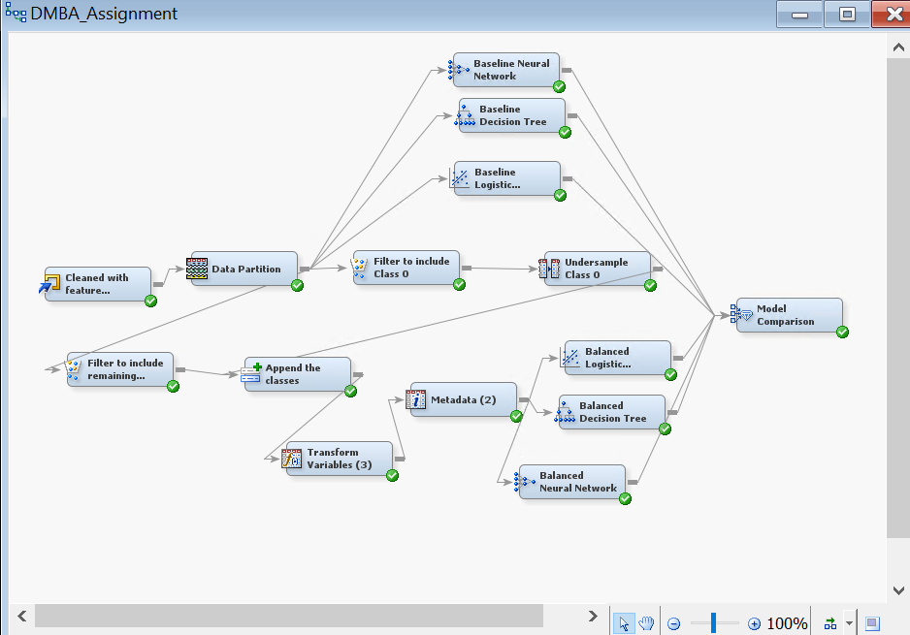

Interpretation and Recommendation (20 marks, 10%)

Detail your interpretation of the results obtained
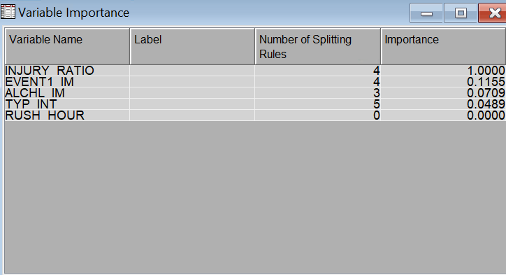

Key Predictors:

The decision tree model's variable importance is highlighted in the table. With four dividing rules and an importance score of 1.000, INJURY RATIO is the most significant feature. With importance values of 0.1155 and 0.0709, respectively, EVENT1_IM and ALCHL_IM come next, showing up in 4 and 3 splits. RUSH HOUR has no effect with 0.000 and is unused, although TYP_INT has little influence with 0.0489 and 5 splits. This suggests that the most important predictor is INJURY RATIO, with other factors making a smaller contribution.

I determine whether the results are good by making sure the metrics such as accuracy, recall etc. are good, there is no overfitting or underfitting present in the data. There are no issues with the model such as class imbalance which can skew predictions that would cause unfairness in the results.

What are some limitations of your analysis?

Class imbalance is my analysis's main flaw since it impairs the model's capacity to predict correctly under-represented groups. The model may favor the majority class because it was trained on an unequal distribution of cases, which could result in biased predictions and a decreased capacity to correctly identify severe but less common cases. This may affect how fair and dependable the models’ predictions are overall. Overfitting is another disadvantage, which lowers the model's capacity to generalize effectively to new data by capturing noise or unnecessarily specific patterns from the training set. The model may be overly dependent on patterns that do not hold in fresh data, even if the training and test misclassification rates are similar. When utilized in practical situations, this could result in poor performance. My last limitation in my analysis is that I did not use a vast number of models and only used logistic regression, decision tree and neural network even though there are many other classification models like gradient boosting and ensemble methods.

What are some of the questions you would have asked the stakeholders if you had access to them?

To increase the accuracy of the model, I would enquire with stakeholders about the best ways to get more accurate data, such as seatbelt usage, airbag deployment, driving conditions, and vehicle maintenance history. To obtain more in-depth knowledge, I would also look at outside data sources like accident records, insurance claims, and traffic camera footage. I would also ask about eliminating potential reporting biases, combining important characteristics like vehicle type or speed limitations for improved interpretability, and harmonizing with standardized injury classifications utilized by hospitals or law enforcement. Finally, to further improve the predictive power of the model, I would think about adding temporal analysis to find patterns in injury severity over various time periods.

How can you improve your model

Resolving class imbalance by resampling or class weighting will help me enhance my model and avoid bias towards the majority class. I can use hyperparameter optimisation, cross-validation, and feature selection refinement to lessen overfitting. Further investigation into models such as ensemble techniques and gradient boosting may improve performance. By recognising important interactions, obtaining temporal trends, and applying domain-specific insights, I may provide better and more relevant features for feature engineering. Furthermore, dimensionality reduction methods like Principal Component Analysis (PCA) can assist in eliminating unnecessary features, lowering noise, and enhancing effectiveness.

How would you expand this project if you had more time?

To increase predictive accuracy, I would broaden this project if I had more time by adding new data sources, such as current traffic conditions and vehicle safety features. To compare their performance, I would also investigate more complex machine learning models, such as ensemble techniques like Random Forest, Gradient Boosting, and deep learning methodologies. To get deeper insights, spot any biases or holes in the data, and investigate other variables that can improve the model's predictive ability, I would also conduct extra analysis on the NHTSA dataset. Also, with more time, I would spend it trying to create a model where there are no class imbalance and no overfitting, which I failed to do.

What are some other data sources that you feel would have improved the results of your predictive model?

My model might be enhanced by additional data sources that offer more information on the severity of injuries. The availability of traffic and road conditions data would help predict the severity of the injury. Airbag deployment and crash test scores are examples of vehicle safety elements that may demonstrate how car design influences injuries. Data on driver behaviour, such speeding and distracted driving, may be useful in determining danger. Data on medical responses, such as hospital proximity and emergency response times, may show how rapidly victims receive care and how it affects the severity of their injuries.

What are your recommendations for stakeholders?

To lessen the severity of injuries, drivers should refrain from driving while intoxicated, which is one of the highest predictors, speeding, and being distracted. Airbags and anti-lock braking systems (ABS), which keep wheels from locking up when braking suddenly and reduce skidding while enhancing vehicle control, should be improved by car manufacturers. Making safety ratings more widely available can also assist customers in making wise decisions. Through more severe penalties on alcohol usage on roads and speeding and awareness-raising initiatives, law enforcement should strengthen their presence in high-risk regions and encourage safe driving. Traffic management systems, lighting, and road infrastructure, especially intersections, one of the highest predictors should all be improved by city planners. Ambulance dispatch should be optimized, and emergency services should make sure hospitals in high-accident locations have adequate equipment. Working together, stakeholders can greatly increase road safety and lessen the severity of injuries.

References (if applicable)

[ Include any websites, videos, books, articles, reports you referenced]

***** END OF ASSIGNMENT 1 REPORT*****
***** END OF ASSIGNMENT 1*****

